San Jose State University
Department of Computer Engineering

=============================================================
CMPE 140 Fall 2010

Final Project Lab Report

Enhanced and Pipelined MIPS Processor

Submitted by: _Gregory Enriquez & Deian Georgiev_ (print)

Date Performed: __7 December 2011__

Checked by: _______Alex________(print)

___________________________(signature)

Lab Section: #1

Final Lab – Enhanced and Pipelined MIPS Processor

Gregory Enriquez & Deian Georgiev
Computer Engineering Department, College of Engineering
San Jose State University, San Jose, CA 95192
E-mail:gregoryenriquez@gmail.com

Abstract
The overall objective of this lab was to take an existing basic single-cycle MIPS processor design and enhance it to support both additional instructions as well as a pipelined design. The methods implemented in order to complete the previously stated objectives are to begin with design, continue with implementation and simulation, and last to prototype on a Nexys2 FPGA board. The results of the lab were successful in that the enhanced and pipelined MIPS processor was able to be verified during simulation and also validated during the prototyping stage. The conclusion of this lab was that a processor design can support additional instructions as well as a multi-stage pipelined design.

Introduction
The first task of the final lab for this course was to extend the given MIPS Instruction Set Architecture (ISA) in an initial implementation to support more instructions. The currently support instructions in the given Verilog code were addition (ADD), subtraction (SUB), an AND operation, an OR operation, set-less than condition check (SLT), load word from memory (LW), store word to memory (SW), branch-if-equal (BEQ), and final the jump instruction (J). The required instructions to extend into the MIPS ISA were: add immediate (ADDI), subtract immediate (SUBI), multiply (MULT), move-from-hi-register (MFHI), move-from-lo-register (MFLO), jump register (JR), and jump-and-link (JAL). The importance of this task during this lab is to understand how an instruction is implemented in a processor as well as what design changes must be made in order to support its operation. In addition to having to modify or in some cases add control signals to the control unit, additional modules, typically multiplexers are required to change the data flow inside the datapath to support new operations.
The final lab for this course is a culmination of not only the previous lab assignments but also that of knowledge found during lectures. While the single-cycle MIPS processor design is capable of performing identical instructions found in a pipelined version, the single-cycle processor we have found is largely flawed in that it does not utilize all the modules within the datapath at the same time. For instance, many of the modules found in the datapath such as the Arithmetic Logic Unit (ALU) use combinational logic and retain the same signals for a large percentage of a single clock period. It is also important to note that one of the only ways of increasing the performance of a single-cycle MIPS processor is to increase the frequency of the clock. This performance solution also has inherent errors in that not every instruction requires the same of time during a cycle, with the load word (LW) instruction being the longest. A diagram of the single-cycle MIPS processor is shown below in Figure 1.
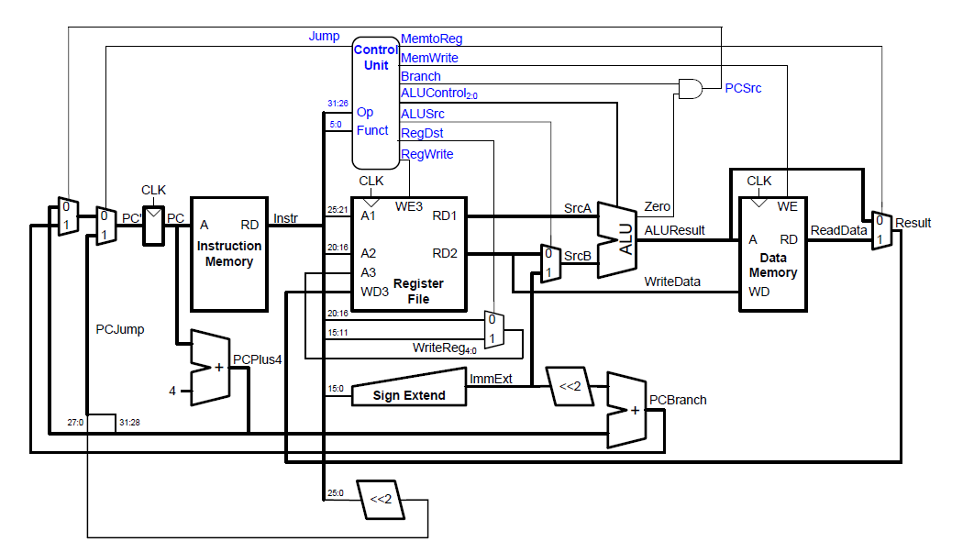
Figure 1. Single-Cycle MIPS Processor Sample [2]

The solution to this problem is the pipelined implementation of the MIPS processor. The pipelined implementation does not require that the clock frequency to necessarily increase in order to increase performance. The pipelined design shown in Figure 2 illustrates how the design from Figure 1 is modified in order to support pipelined operations. The pipeline registers, denoted by long vertical rectangles shown in Figure 2 divides the cycle in a single-cycle design into five different stages: Instruction Fetch (IF), Instruction Decode (ID), Execute ALU (EX), Memory (MEM), and Write Back (WB). These pipelines are what enable the design to increase throughput without having to increase the clock frequency. In the IF stage the instruction is simply read from the Instruction Memory (IMEM) based on the current process counter and loaded into the IF pipeline. In the ID stage the instruction is then sent to multiple modules (as it does in a single-cycle design) with the two primary modules being the Control Unit (CU) and the Register File (RF). In this stage, the CU sets control signals based on the instruction read which include multiplexer (MUX) selection, the ALU control signal, the write enable signals, and conditional signals such as jump and branch. It is important to note however, because it is a pipeline design, not all the MUX signals coming from the CU affect the operation in the current stage. Instead, the MUX signals are carried through the following pipeline and affect later stages, which is one of the primary intentions of using a pipelined processor. The next stage of the pipeline implementation is the EX stage where the ALU executes an operation on two input sources which will either be for basic arithmetic functions or to calculate an address to determine a location in either the data memory. The next stage is the MEM stage where data is either written to, or read from the data memory module which simulates the random access memory (RAM) of our MIPS processor. The final stage, WB, is used to store ALU result outputs or data from the data memory via the LW operation. Altogether, the five stage pipeline implementation carries a heavy advantage over the single-cycle implementation at the cost of complexity. A diagram of the original pipeline design is shown below.

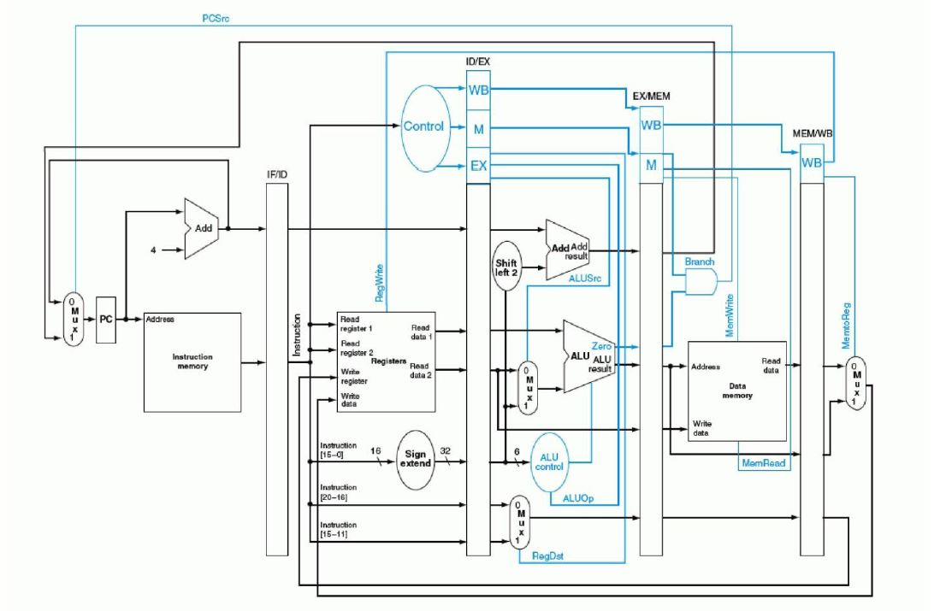
Figure 2: Initial Pipeline Design Sample [2]

Although the MIPS pipeline implementation increases the throughput of the MIPS processor by a significant amount it does come with somewhat of a large cost also—complexity. The first part of the complexity involved in a MIPS pipelined processor is designing the pipeline registers themselves. The designer must first determine where the pipelines should be placed since they divide the modules of the datapath into their respective stages. As noted in the previous section, the pipelines per strategically placed to divide the primary modules of the datapath: instruction memory, RF and control unit, the ALU, the data memory, and the register file during write operations. The next area where complexity is encountered in the MIPS pipelined design is hazard unit control. A disadvantage of using a pipelined design is that certain contents in registers may not be the expected contents during an operation. Because the datapath is split, for example, a read operation from the register file may not have the correct contents because a previous instruction is still in another stage of the pipeline waiting to write a value to the RF in the Write Back stage. The solution to this issue is the inclusion of a Hazard Control Unit (HCU) into the design. The HCU is responsible for feeding back signals to previous modules because the data has not yet be written back to the RF. The two types of hazards are data hazards and control hazards. Data hazards are the same as denoted above with incorrect contents being read while control hazards are situations where a condition is incorrectly decided. There are four means in which to deal with data hazards in a pipelined design: (a) insert nop operations, (b) rearrange code at compile time, (c) forward data at run time, and (d) stall the processor. An illustration of a HCU in a pipelined MIPS processor is shown below.

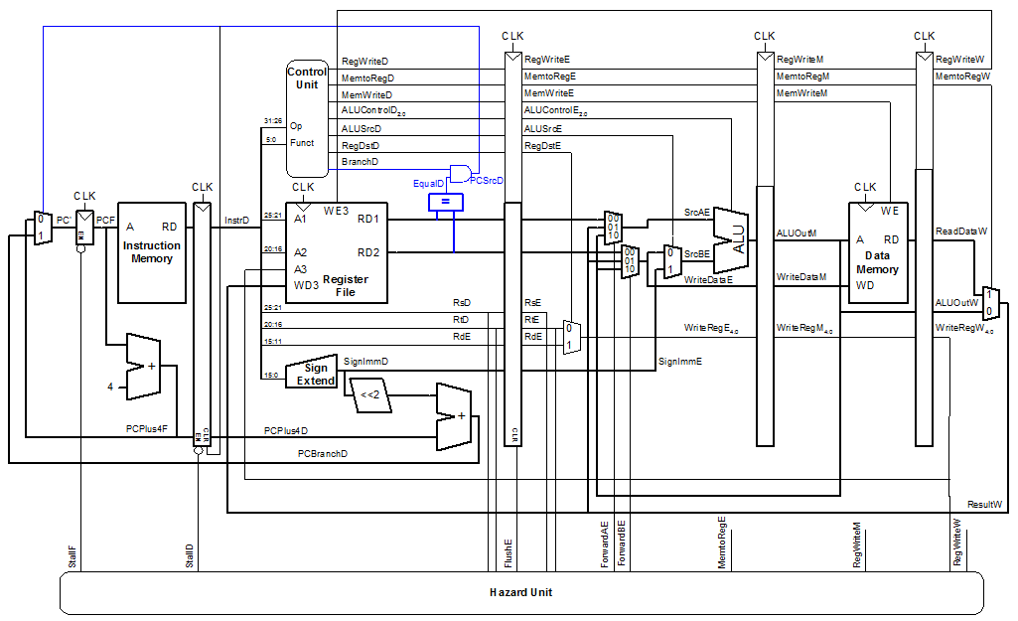
Figure 3: Pipeline Design with Hazard Control Unit [2]

The hardware process invoked during this lab consisted of five phases: design, implementation, verification, synthesis and prototyping. These five phases were actually conducted twice during the completion of this lab with the first iteration being the instruction extension and the second being the pipeline implementation with the extended instructions already in place. The tasks involved in each of the phases are discussed in the following section below.

Task and Methodology
Tools Used: Microsoft Visio 2010, MIPS Assembler and Simulator, ModelSim Simulator, Xilinx ISE WebPack

The tasks for the final lab were divided into two primary parts with Part 1 being the extension of the MIPS instruction set architecture and Part 2 being the implementation of the pipelined MIPS processor. These two parts are covered in depth in the next following sections below.

Part 1: Design
Initially, the first phase of the design was to design the MIPS processor with pipelined registers; however, after careful consideration we chose instead to begin the lab by extending the instructions of the single-cycle MIPS processor. Using Microsoft Visio 2010, we modified the initial design shown in Figure 1 to the revamped design shown in Figure 4. It was discovered that support for the ADDI instruction had already been implemented in the given Verilog source code so there was no need to modify the design in order to support the instruction. Similarly, we also found that the SUBI instruction upon compilation in the MIPS Assembler and Simulator, changed the instruction to an ADDI instruction with a negative immediate value; therefore, there was no need again to modify the design to support it.
The MULT instruction was the first instruction that required modification to the design. The first modification to the design to support to the MULT instruction was the introduction of the $hi and $lo registers. These special registers are not located inside of the RF; instead they are special and separate registers in their individual modules. The changes made to the single-cycle design are denoted in red in Figure 4 below. The $hi and $lo registers are located towards the right of the design just below of the data memory in red. These registers

Figure 4. Single-Cycle MIPS Processor with Instruction Extension

required the output of the multiplication operation in the ALU be sent to both at the same time with a write enable for the $hi and $lo registers. The upper 32 bits of the ALU output should go to the $hi register and the lower 32 should go to the $lo register. This required that the ALU support a multiplication operation and also that the result be expanded to a 64-bit output. We later found out however that the multiplication operation should have a separate ALU that is dedicated for multiply and divide, which will be mentioned later.
The next two instructions: MFHI and MFLO were very similar in terms of design. Both required that the data from the $hi and $lo registers be available to read and a path placed so that they could write back into the register file module. This required that a MUX be placed to control which data would be writing back to the ALU: either the contents of $hi, the contents of $lo, or the result of the selection between memory data read or out of the ALU. A 4-to-1 MUX was included to select between the three data signals, with the last slot reserved for future extended instructions. Once these modules were in place with a 2-bit selector the 4-input MUX, we then moved on to the next instruction. The next instruction required to add into the design was the jump-and-link (JAL) instruction. The JAL instruction is a J-Type and also requires that the current process counter (PC) + 4 be saved to register $ra. The JAL instruction is similar to calling a function where it must return after the function is complete. For our design, we included a MUX just in front of the write address (WA) of the register file and hard-coded a value of 31, which is the register number for $ra. Additionally, we also directed the PC + 4 value to be selected before the write data (WD) input of the register file to ensure that the address is saved to that particular register. The final instruction required to add into the design of the single-cycle MIPS processor was the jump register (JR) instruction. The JR instruction is an R-Type instruction where the bits [25:21] of the 32-bit instruction are the address of the data inside the register file. The data at the address contains an address that will be sent back into the PC and read from that address in the instruction memory. The JR instruction typically follows the JAL instruction since the JAL instruction saves the address and the JR instruction reads the address.

Implementation
The implementation phase of part 1 of the final lab required us to modify the existing given Verilog code for the single-cycle MIPS processor by following our new design shown in Figure 4. In addition to basic wire, input and output signals, the implementation of the extended instructions changed the original Verilog source code in a few ways. The first section of code that was modified was the control unit which dictates the behavior of the connected modules in the datapath. The included signals into the maindec module was only the jalSel signal which is the selector signal for the JAL instruction MUX’s: dstjalmux and jalmux. The dstjalmux MUX is responsible for selecting that the PC + 4 value be sent to the register file while the jalSel MUX selects the hard-coded value of 31 to the write address of the RF.

[design cont]
[implementation]
[verification]
[sim tables]
[synthesis]
[prototyping]

Testing and Verification
This section provides detailed description of your testing method, your observations, as well as your analysis. Necessary figures, tables, screen captures should be included along with your description.
[prototyping results]
[hardware verification table]

Conclusion
The report conclusion summarizes the results/accomplishments, as well as your suggestions and/or the problems you may have encountered.

References
[1] D. Hung, CMPE 140 Handouts, Computer Engineering Department, College of Engineering, San Jose State University, 2010.
[2] D. Patterson & J. Hennessy, Computer Organization and Design, 4th Edition, Morgan Kaufmann Publishers, 2009.

Appendix
The appendix will include source code listing and other necessary information.

